

**Winding and unwinding extraordinary monetary policy**

# Speech given by

David Miles, External Member of the Monetary Policy Committee, Bank of England

RBS Scottish Economic Society Annual Lecture, Edinburgh 11 September 2012

I would like to thank Jochen Schanz and Arpad Morotz for research assistance, and others for helpful comments. The views expressed are my own and do not necessarily reflect those of the Bank of England or other members of the Monetary Policy Committee.

All speeches are available online at [www.bankofengland.co.uk/publications/Pages/speeches/default.aspx](http://www.bankofengland.co.uk/publications/Pages/speeches/default.aspx)

### Introduction

If cities competed for the title of the birth place of economics then Edinburgh would be one of the favourites. Hume and Smith would be contenders for individual medals. But such is the low popular standing of economics I rather doubt that there is much enthusiasm for handing out medals right now. This is not hard to understand: we have been through a near total collapse of the financial system followed by one of the deepest and longest recessions in history. I use “we” to include most of the western, rich world. Very few economists predicted this – though some warned about excesses in parts of the financial system and imbalances that might cause problems.

But I am not going to apologise for the supposed failings of economics. In fact I am honoured to be asked to deliver the Scottish Economic Society Annual Lecture. I am going to talk about monetary policy and how it has been operated in the extraordinary – and I mean extraordinary in a bad way – environment of the past

5 years. I will assess whether some alternative policies might be more effective. I will also consider how we might get back to a more normal setting for monetary policy and whether we need to rethink the aims and tools of policy.

Before I get to that let me take one and a half minutes to say why I don’t feel inclined to devote time to apologising for the failings of economics. One reason is that the value of economics should not be gauged by how well economists can forecast the future. It is unfortunate then that many people are encouraged to think that this is pretty much the only yardstick to use. I think if you judged modern medicine by the same criterion you would not think it very valuable. But of course we don’t do that. We believe doctors are worth listening to if we have a broken leg or have a brain tumour even though they may not have been able to predict that you would be in that unfortunate position. A second and stronger reason not to spend time apologising for economics is that one of the main criticisms made of it is so spectacularly wrong-headed that it should not be taken seriously. This is the criticism that economists became convinced that the actions of rational economic agents in shaping market outcomes would inevitably lead to stable and efficient outcomes. According to this criticism, since we have plainly not had stable and efficient outcomes over the past 5 years, then it would seem to follow that the guiding principles of economics are deeply flawed. Those who think they are presenting a sophisticated version of this critique will specifically mention the rational expectations and efficient markets hypotheses. In fact all the efficient markets hypothesis really says is that financial outcomes are pretty much unpredictable – not that they are desirable or efficient in the everyday meaning of that term. And the rational expectations hypothesis is really a way of thinking that stresses the importance of people’s anticipation of future events in driving their decisions; it in no way means that the collective implications of such decisions must be optimal. In fact any undergraduate economics textbook spends a lot of time showing why market outcomes can be – and often are – sub-optimal. Economic thinking at the frontier of the subject has – for at least thirty years – stressed that a combination of rational behaviour by

individuals and interaction between people in markets where there are information problems creates the potential for outcomes that are not at all likely to be optimal.

One indication of the dominance of this type of thinking – a type of thinking completely at odds with the caricature that economists claim that free market outcomes are stable and efficient – is the list of economists who have won Nobel prizes. The largest group of people on that list won their prizes for work which showed that market outcomes could often be inefficient and sometimes unstable1. See Annex 1.

I find economic thinking very helpful in trying to understand why we have got into such a mess and, more importantly, how we might get out of it. Tonight I want to describe the part that monetary policy is playing, consider whether alternative policies might be more effective and explore some of the longer-term consequences of what we are still going through. I start by describing how policy has evolved over the past 5 years. Then I will assess whether monetary policy has stopped being effective and if a more radical step – explicit monetisation of government spending – is required. Finally I consider what the lessons from this extraordinary period are for the design of policy and assess how, in due course, the transition back to a more normal monetary policy might be made.

### Monetary policy during the crisis

Monetary policy has been trying to offset extraordinary recessionary forces that arose in the wake of a near collapse of the banking system of the western world.

The measures that have been taken to counter the extraordinary forces at play have themselves been extraordinary. In the UK Bank Rate was lowered rapidly, from 5.75% in December 2007 to 0.5% in

March 2009. Even with Bank Rate at 0.5%, it looked like demand would be so weak that the economy would descend further so that inflation might undershoot its target in the medium term.

Reducing Bank Rate further would have had the advantage of using an established instrument to implement monetary policy. But lowering Bank Rate would also have had disadvantages. First, it is not clear whether it would have substantially eased the supply of credit at those longer maturities that matter for consumption and investment. And second, it may have adversely affected the stability of a number of banks and building societies, whose profit margins were already squeezed: their interest income had fallen much more than their funding costs because they had a considerable stock of mortgages with interest rates contractually linked to Bank Rate, not to their own funding costs. I think there were reasons to believe that the benefits of cutting

1 In the annex I provide a list of winners and an (admittedly subjective) allocation of them to one of three groups: 1. Those for whom incomplete markets, or asymmetric information, or moral hazard-adverse selection, or externalities, or coordination problems are central (eg Akerlof, Mirrlees, Spence, Stiglitz): 2. Those for whom those issues are not very relevant (eg the econometricians – Engle, Heckman, McFadden, Granger): 3. Those for whom even though information issues are central, the laissez faire outcomes are still likely to be the best realistically available (eg Friedman, Lucas, Prescott, Coase). The first of these three groups is significantly larger than the other two; I would put almost half of the winners in it (see Annex).

Bank Rate further were, at best, likely to be small and that the effects could well be perverse. I see no obvious reason to think things are much different today, though this is something to keep monitoring.

**Figure 1**: Bank Rate (a)

18

16

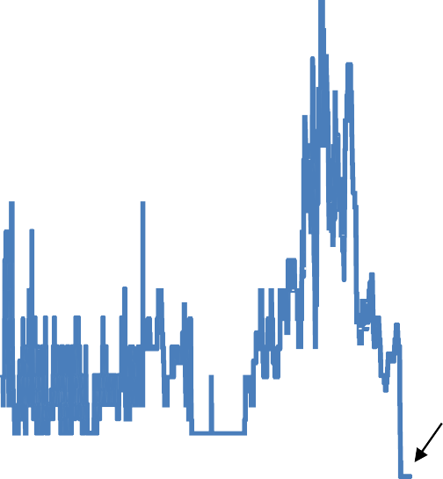

Mean: 4.8%

SD: 2.2%

Previous low: 2%

2012

14

12

10

**%**

8

6

4

2

0

1694 1744 1794 1844 1894 1944 1994

Source: Bank of England.

(a) Depicted are the Bank’s respective key rates over time: bank rate, minimum lending rate, minimum band 1 dealing rate, repo rate, and official Bank Rate.

With Bank Rate at 0.5% monetary policy has been further loosened through two other routes.

First, the MPC embarked on asset purchases, aiming to increase the availability, and cut the cost, of funding (via equity or bond issuance or by other borrowing) for the private sector. One means would have been to purchase directly large quantities of private sector assets. This is what the Federal Reserve System did when purchasing mortgage-backed securities (though in fact most of such assets had the backing of government agencies which made them closer to government bonds than private sector assets). The MPC has instead decided that its – now enormous – asset purchases should be overwhelmingly of government bonds2. The people that sell those bonds to the Bank then have to decide which alternative assets to acquire – these could either be claims on UK private sector entities (eg claims on UK companies that have issued bonds or equities or deposit claims on banks) or claims on foreign entities (by acquiring foreign equities or bonds or other debt claims issued by overseas companies and governments). The MPC has taken the indirect route of buying gilts and then letting the sellers make the portfolio allocation decisions that

2 The Bank has purchased some private sector assets (corporate bonds and commercial paper), aiming to improve the liquidity in, and flow of, corporate credit; but the amounts have been small compared to purchases of gilts. As of 23 August 2012, the Bank’s asset purchase portfolio contained £346bn in gilts, £91mn in corporate bonds, and no commercial paper. The bank is still operating (as buyer and seller) in the corporate bond market.

mean that the funds they get from the Bank are channelled into other places. It seems highly likely to me that many of those funds have been channelled into the UK corporate bond and equity markets3. Some of the money has certainly gone towards buying claims on overseas assets – in which case that is likely to have an exchange rate impact as well as having effects on the domestic economy as the sterling is recycled.

Some of the money flows directly to banks and stays with them – potentially helping with bank funding and liquidity problems that have at many times over the past few years been acute.

One can argue about how effective all this has been in offsetting the recessionary impact of the financial crisis. But let me note in passing that one thing one *cannot* do is to take as proof of its ineffectiveness the fact that reserves held by banks at the Bank of England have gone up enormously. It is a mistake to see that as proof that somehow the money created by QE has got “trapped” in the banking sector and is doing no good. Creating reserves (that is commercial bank deposits at the Bank of England) is how the Bank of England finances its asset purchases. So it is not surprising that banks’ reserve balances increased by a lot (Figure 2) – it is simply a matter of arithmetic.

**Figure 2**: The Bank’s liabilities and assets, including outstanding amounts of lending facilities (a)

## £ bn Other liabilities Short‐term open market operations 450

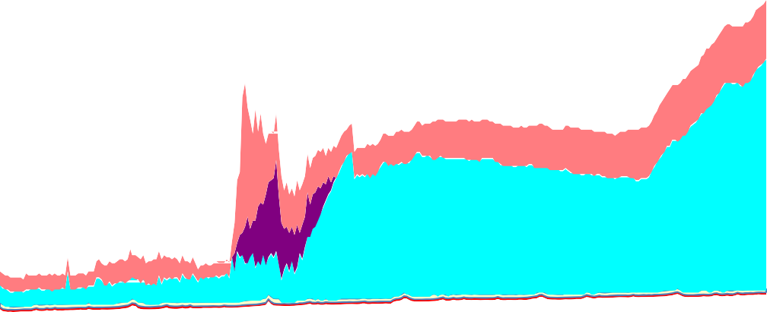

Reserve balances

Foreign currency public securities

Cash ratio deposits

Notes in circulation

400

350

300

250

200

150

100

50

0

2007 2008 2009 2010 2011 2012

3 Sterling corporate bond issuance in 2009 was unusually high as is issuance in 2012.

# £ 450

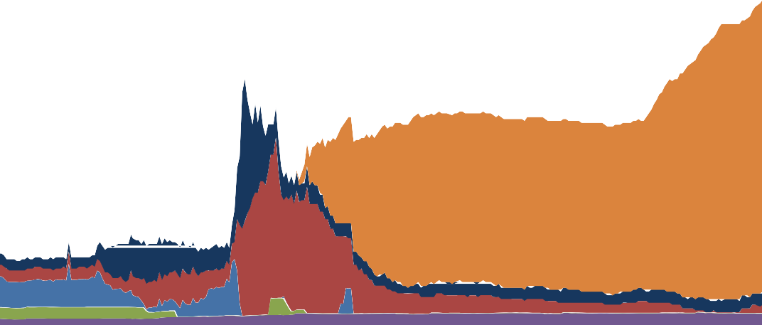

bn

'Asset purchases' (b)

Other assets

Longer‐term sterling reverse repo Short‐term open market operations Ways and means

400

350

300

250

200

150

100

50

0

2007 2008 2009 2010 2011 2012

Source: Bank of England.

1. Weekly data, up to 22 August 2012.
2. ‘Asset purchases’ is the quantity of asset purchased by the creation of central bank reserves by the Bank’s asset purchase facility (APF); these are reflected by a loan to the APF on the Bank’s balance sheet.

The money is going to come to sit at the Bank as reserves even if by its creation it has triggered multiple other transactions that have helped finance spending in the economy. This point is not well understood so let me take one minute to illustrate it.

Suppose the Bank of England buys an extra £1 million of gilts; the seller effectively gets a cheque drawn on the central bank. That cheque is cashed and so the bank of the seller of the gilt credits the seller’s account and the cheque is presented to the Bank of England who credits the account of the commercial bank. So bank deposits are higher as are reserves held by banks at the Bank of England. Suppose the seller of the gilt now buys a newly created corporate bond that will finance some new investment. The bank account of the company that issued that corporate bond goes up and that of the buyer of that bond goes down. Some money will flow between two commercial banks if the buyer and seller of the corporate bond have different banks – if that happens some reserves at the Bank of England will move from one bank to another. The total level of reserves held at the Bank of England will not change. Now suppose in the next stage the company that issued the corporate bonds spends the money on investment, which means more wages and profits get generated somewhere else and so the money flows into bank accounts somewhere else. Economic activity is likely to be higher. Reserves may move (many times) from one bank’s account at the Bank of England to another. But aggregate reserves held at the Bank of England will not change at all. Just looking at what has happened to total reserves at the Bank of England tells you nothing about this. Nothing. If all that economics taught us is this it would have done some good.

### Figure 3: Stocks of gilt holdings by sector (a)

£ bn 1500

Other (households, local authorities, public corporates, PNFCs)

Insurance corporations and pension funds Other financial institutions

Non‐residents

UK MFIs, excl. Bank of England Bank of England

1000

500

0

2005 2006 2007 2008 2009 2010 2011 2012

Sources: ONS and Bank of England.

(a) Market values. All maturities. Total excludes central government holdings.

Figure 3 shows who was holding gilts before and during the Bank’s purchases (the last observation is 2012Q1). The government, net, has issued more gilts since 2009 than the Bank purchased. [In fact, among the sectors that Figure 3 distinguishes, only the gilt holdings of ‘other financial institutions’ declined – these include, for example, securities and derivative dealers, mutual funds, and mortgage lenders.] But the fact that net issuance was larger than the Bank’s purchases does not mean that the effect of the Bank’s purchases was diminished. The impact of a policy has to be judged against what would have happened in the absence of the policy action. And unless one believes that net issuance of gilts would have been significantly lower had the Bank not purchased gilts, the private sector would have had to absorb a much larger stock of government debt. All else equal that would have reduced the supply of credit to the private sector. The Bank’s purchases worked to offset that.

I am not going to describe in detail the empirical evidence on the impact of the Bank’s gilt purchases on the economy; this has been done elsewhere*.*4 I believe the evidence is that it has had a significant positive effect. Colleagues of mine at the Bank of England estimated that purchasing £200bn worth of gilts during 2009-10 may have increased GDP by 1.5-2%. The fact that GDP itself has been more or less stagnant for much of the past eighteen months is not clear evidence that QE has become ineffective; it is evidence that the forces holding back a recovery remain powerful.

4 See, for example, George Kapetanios, Haroon Mumtaz, Ibrahim Stevens and Konstantinos Theodoridis (2012), ‘Assessing the economy-wide effects of quantitative easing’, *Bank of England Working Paper No. 443*, and Michael Joyce, Matthew Tong and Robert Woods (2011), ‘The United Kingdom’s quantitative easing policy: design, operation and impact’, *Bank of England Quarterly Bulletin*.

Instead of focusing on the impact of QE on growth, attention has tended to concentrate on the reduction in gilt yields, probably because the impact of gilt purchases was most visible here. But it was never the ultimate objective of gilt purchases to lower gilt yields, just as a reduction in Bank Rate never has as its ultimate objective to lower yields on Treasury bills. Lowering gilt yields is only the first – and not necessarily the most important – link in a longer transmission mechanism whose overall effect is to increase the availability of funding for the private sector, raising demand for goods and services. The impact that the Bank’s asset purchases had on the spreads between gilt yields and yields on corporate bonds, and on different types of bank lending, has been at least as important for the economy as the impact on the yields on government bonds.

The second means by which the Bank loosened monetary conditions was an expansion of its lending facilities.5 With some facilities this worked by increasing the extent to which the Bank insures solvent banks against liquidity outflows. Figure 4 is a stylised representation of the evolution of the Bank’s lending facilities during the crisis. Movements in the North East direction in the figure represent a widening in collateral and an extension of the maturity of lending. In most cases such movements represented an easing in funding conditions for banks. Liquidity insurance will be used more the lower the interest rate charged, the wider the type of collateral accepted, and the greater the range of time horizons for which the central bank lends.

In normal times, the interest rate is the most important feature of the Bank’s lending facilities: when banks’ liquidity and solvency are not in doubt, banks are able to offset liquidity outflows with funds raised in private markets. So they only borrow comparatively small amounts of funds from the central bank. But in the recent crisis, banks had on occasion substantial difficulties in raising funds in private markets because investors doubted both their liquidity and solvency. Had the Bank offered to lend only against the highest-quality collateral, and only at a very short maturity, banks’ liquidity risk may not have fallen back significantly from crisis levels. The term and the collateral requirements of its lending operations became important determinants of monetary conditions. By expanding these facilities, monetary conditions eased because a more comprehensive insurance of banks’ liquidity risks increased their willingness to grant longer-term loans to the private sector.

5 See <http://www.bankofengland.co.uk/markets/Documents/sterlingoperations/summaryops120705.pdf>for a summary of the Bank’s current operations in sterling money markets.

**Figure 4:** Evolution of Bank of England’s lending facilities during the crisis

### Collateral eligibility criteria



Wide

6 month

ECTR (2012-)

1, 12 month

DWF (2011-)

FLS

3 month 3 and 6 month

1, 12 month

DWF (2008-11)

SLS (2008-09)

Medium

ELTR (2008-10)

ILTR (2010-)

3 month ELTR

(2007-08)

Narrow

1 week OMO

(-2009)

3 months

1 week

3, 6, 9, 12 month LTR

(2006-10)

12 months

6 months

3 years

4 years

### Maturity

Note: This chart offers a subjective ranking of most of the key facilities via which the Bank offered reserves, Treasury bills or gilts to its counterparties at various times since 2007. The facilities shown are 1 week open market operations (OMO), long-term repos (LTR), extended collateral long-term repos (ELTR), indexed long-term repos (ILTR), extended collateral term repos (ECTR), the discount window facility (DWF), the Special Liquidity Scheme (SLS), and the Funding for Lending Scheme (FLS). Notice that the schemes differ in other dimensions than maturity and collateral requirements. See <http://www.bankofengland.co.uk/markets/Pages/default.aspx>for details.

### Is monetary policy no longer effective?

Despite the extraordinary monetary policy measures taken, growth in the UK has been anaemic – output has stagnated for more than a year. Some people take that fact – the fact of weak output – as proof that monetary policy has stopped being effective and, more specifically, that purchases of government bonds (what you might call conventional QE) is no longer effective. I think this is not very convincing because it ignores the range of factors which have restrained demand and which might have caused output to fall significantly had not an increasingly expansionary monetary policy been pushing back in the opposite direction. It is not as if it is hard to identify such forces – one of which is the clear deterioration in the funding conditions for banks across Europe that began in the Autumn of last year and which was followed by falling confidence across most of Europe and stagnation in economic activity.

I am unconvinced that the stagnation we have seen over the past eighteen months in the UK is proof of the ineffectiveness of monetary policy. But I do take seriously the suggestions that alternatives to what I have

called conventional QE might be more powerful in boosting demand. One suggestion is that the MPC should undertake money financed spending – sometimes called a helicopter drop of money. My view on this can be summarised quickly: Either money financing (or helicopter drops) is done in a way which pays no attention to the inflation consequences – in which case it is not a very attractive policy – or it is done in a way which is sensitive to the longer-term inflation consequences, in which case the differences with conventional QE largely evaporate. Let me explain.

It is useful to start by asking what is money financed spending (or helicopter drops)? One could think of this as the Bank of England sending a cheque to every household in the country. Would a £1,000 Christmas bonus for every family in the UK from the Bank be a good idea? Let me make several points about the economics of this. In doing so I will put to one side the important question about the legitimacy of the MPC embarking on what looks like fiscal decisions – I just want to focus on the economics of the thing and ask how this strategy differs from what I have called conventional QE. Let me start by saying that what I have described as the Bank giving all families a Christmas Bonus is equivalent to a lump sum temporary tax cut – a one-off reverse poll tax – financed by new issuance of government bonds (i.e. standard fiscal policy) followed by the central bank buying those bonds in the secondary market a few moments later and then channelling all the coupons and redemptions on those bonds straight back to the Treasury.

How is monetary part of this like conventional QE and how does it differ? It is like QE in the sense that the coupons and redemptions from the gilts the Bank has already bought are flows of money from the government that are accumulated in a fund that is effectively owned by the government. It is also like QE in that the policy can be reversed later on: with QE, the gilts can be sold, and with money-financed spending, the government could later increase taxes temporarily to recoup what it had paid out to households. The bank reserves that are created as a by-product of the Bank’s QE gilt purchases are not zero-interest bearing money (as in a Friedman style helicopter drop) – they pay Bank Rate. But they do so in an environment in which Bank Rate is close to zero.

The QE gilt purchases by the Bank are not guaranteed to be permanent – they can be reversed. Whether and when they are reversed will depend on inflation conditions and on what level of reserves the banking system comes to want to hold. Bank Rate will also depend on inflation conditions. So the key difference between the helicopter drops of money (which is money financed fiscal policy) and conventional QE is that, with the latter, the terms on which the asset purchases by the central bank are made are flexible and sensitive to inflation pressures in the economy, while with money financing they might not be. If Bank Rate is kept close to zero, if coupon payments on gilts are channelled back to the government and if new bonds are bought as old ones mature, then conventional QE looks very much like money financing of government spending (helicopter drops of money). If Bank Rate is increased, or if the stock of government bonds held by the Bank are run down, it will come to be less like helicopter drops of money. How much like helicopter drops it is depends on subsequent monetary policy decisions made in the light of inflation pressures. Why

would one not want that? Why would irreversible helicopter drops be superior, when they might ultimately generate inflation pressures that would be unwelcome6? Why not prefer a more flexible policy where asset purchases can be adapted if inflation pressures pick up and the demand stimulus they generate no longer brings forth more output but instead just creates higher prices? Surely one wants unconventional monetary policy to boost demand when that generates more economic activity but to have a declining impact once the extra demand is largely showing up in higher prices rather than in volumes. To my mind this is exactly what asset purchases – conventional QE – does. ***If helicopter drops of money are reversed when their impact shows up very largely in prices and not in activity, the economic difference with conventional QE largely evaporates.***

The Bank’s asset purchases can be reversed and are financed by the creation of reserves that pay Bank Rate. Therefore they are not the equivalent to permanent money financing of government spending. Yet some have argued that the Bank is effectively monetising the government’s debt and has lost the focus on its inflation target. I believe this criticism is misguided. Monetising the debt would involve the central bank buying up government bonds permanently, and financing the purchase by issuing non-interest bearing liabilities, *independently of predicted inflation*. That is the crucial distinction between QE and what I called helicopter drops of money done in a way that is not adjusted if it later generates inflation. The decision of the MPC to embark on asset purchases on an enormous scale was not done because it had abandoned the inflation target; it was done ***because of*** the inflation target. It was done because the outlook for demand has been so weak that unless monetary policy was set to offset this it was likely that inflation would ultimately be driven below the target level as output languished far below the productive potential of the economy. The fact that many asset purchases were made at a time when inflation was substantially above target meant that many people interpreted it as an abandonment of the target. But that would only be a natural interpretation if the current level of inflation was a good indicator of underlying inflation pressures – and that was clearly not the case for much of 2011 and into 2012. The fact that the Bank has bought £350 billion of assets and that most private sector forecasts now show inflation will remain near the target level is a telling piece of evidence against the argument that asset purchases show that the MPC has given up on inflation targeting. (There is a different argument that the MPC *should* give up on inflation targeting that I will return to later).

### Observations from this extraordinary period

Let me stand back a moment and review what has happened over the past 5 years. Where we have got to is extraordinary: Bank Rate is at its lowest in 300 years and has been there since early 2009; The Bank’s balance sheet has increased almost fivefold7; some £350 billon of government bonds have been purchased by the central bank – and those purchases are continuing. The range of assets that commercial banks can

6 If helicopter drops are not permanent, and the government decides to later reverse their impact if they ultimately raise inflation significantly, then it would need to run a surplus (or overfund) to remove the money that had been created.

7 The Bank’s total assets were £80bn in August 2007, and £380bn in August 2012.

use to borrow against from the Bank of England has been widened; and – more recently – the Funding for Lending Scheme has been launched – a scheme that in some ways sits in the grey area between monetary and fiscal policy and one that I will return to in a moment.

I make three observations on monetary policy in the light of these extraordinary events.

First, it is sometimes alleged that a central bank becomes powerless when short-term interest rates are near zero. The rationale is that at near-zero interest rates, the private sector’s opportunity costs from holding money are also near zero, so the private sector is willing to hold any amount of money that the central bank injects without requiring a further decline in interest rate. The central bank then cannot relax monetary conditions further: the economy is in a liquidity trap.

This is not a good description of where we have been. It assumes that there is only one short term interest rate in the economy. In fact the rates that really matter to the private sector – for example rates charged on business loans, yields on corporate bonds and rates on mortgages – have been far above the policy rate set by the Bank of England. One of the central aims of QE has been to try to stop those spreads widening further and to ease the flow of credit to the private sector. Clearly the cost of bank funding in private markets has remained substantially above Bank Rate. Longer-term lending programmes such as the recently launched Funding for Lending Scheme (FLS) have been designed to increase credit supply by reducing banks’ funding costs, particularly for new lending. The FLS is designed to ease monetary conditions by helping banks secure funding in private markets for a four-year period – a much longer term than that of other Bank lending operations. The scheme incentivises banks to expand lending because funding is cheaper the greater the rise (or smaller the fall) in lending. What makes the scheme attractive to banks is not only the small size of the fee that the Bank charges but, crucially, also the Bank’s willingness to accept collateral that private market participants might refuse. None of this would be necessary if we were in a liquidity trap.

My second observation is that the boundary between monetary and fiscal policy can become blurred in crisis times. I illustrated this above in my comparison of out and out money financed spending (helicopter drops of money) and what I call conventional QE. Gilt purchases might seem to fall into the grey area between monetary and fiscal policy because they lower gilt yields, and reduce the Treasury’s refinancing costs.

The blurring is also to some extent there with all liquidity support operations and with the Funding for Lending Scheme. Lending to banks against a wide range of collateral and for a longer term increases the central bank’s credit risk, so ultimately puts taxpayers’ money at risk. In the Funding for Lending Scheme the Bank accepts a wide range of collateral, including new loans that the banks make. Because the value of the collateral is not guaranteed, this introduces an element of credit risk even in the presence of

over-collateralisation [that is the substantial haircuts that the Bank makes].

My final observation is about the link between the amount of central bank reserves and inflation. It is sometimes claimed that the huge expansion of reserves held at the central bank – which are the counterpart to QE – has to greatly increase inflation at some point in the future. This argument is based implicitly on some version of the quantity equation for money: the supply of money (M) multiplied by the velocity with which money circulates (V) is equal to the price level (P) multiplied by the number of transactions paid for using money (T). That is:

MV = PT

This equation is simply a definition for the velocity of money. But some commentators interpret it as if there were a mechanical link between the growth of reserves (part of a narrow measure of M) and ultimate changes in the price level P. This really asks too much of an identity. Inflation arises when demand for goods and services exceeds the supply potential of the economy at a given price level. My own view is that demand depends on interest rates far more reliably than it does upon a measure of the amount of money. Crucially, as long as the central bank retains control over the short-term interest rate, it can operate monetary policy with a substantially higher amount of reserves. If the Bank did not remunerate reserves at the policy rate, short-term market interest rates might fall below it. By remunerating reserves at Bank Rate, short-term market interest rates are much less likely to fall below Bank Rate: because of arbitrage, investors with reserve accounts – which include all the UK’s major banking groups – should not grant loans at an interest rate below Bank Rate.

The quantity equation if used in a mechanical way omits the impact of interest rates and it tells one nothing about shifts in the demand for money that will make velocity vary. And in fact velocity is highly variable.

Figure 5 plots an estimate of the velocity of narrow money, assuming that the total number of transactions is proportional to real GDP. This estimate of velocity had been around 30 between the early 1990s and 2006, reflecting the low level of central bank reserves, before the Bank started to pay interest on reserves in 2006. It fell further when the banking sector’s reserve holdings increased during the Bank’s asset purchases, falling to a level of about 7 by Q1 2012.

**Figure 5:** Velocity of money, measured as annual nominal GDP / sum of reserves, notes and coin (a)

35

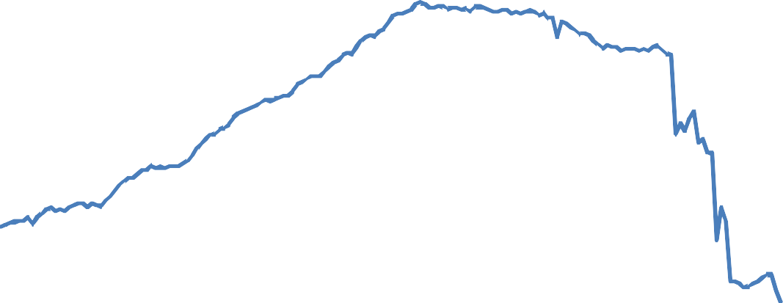

30

25

20

15

10

5

0

1969

1971

1973

1974

1976

1978

1980

1982

1984

1985

1987

1989

1991

1993

1995

1996

1998

2000

2002

2004

2006

2007

2009

2011

Sources: ONS, Bank of England.

(a) Nominal GDP figures are four-quarter backward-looking sums. ‘Sum of reserves, notes and coins’ is measured by the Bank’s M0 series until publication was discontinued in August 1997. From then on it is measured as the sum of monetary and financial institutions’ ‘Other deposits with the Bank of England’ (including reserves) and ‘Notes and coin’ in circulation. All series apart from ‘Other deposits with the Bank of England’ have been seasonally adjusted.

Empirical studies tend to use a broader monetary aggregate, such as M4 – rather than the sum of reserves, notes and coins (also referred to as M0) – when computing the velocity of money. Indeed, the ratio of nominal GDP to M4 is much steadier, having fallen from around 2 during the sixties and seventies to around 1 today (Figure 6). But this does not shed any light on the link between the amount of reserves and inflation, precisely because the relationship between M4 and M0 is as volatile as the relationship between nominal GDP and M0 (Figure 7).

Claiming that asset purchases and the rise in reserves must lead to much higher inflation down the road is therefore wrong. The key factor is whether Bank Rate – and the stock of asset purchases – are appropriately set to meet the inflation target given the relative movements of demand and supply; and, more generally, whether the monetary policy stance is appropriate. Historically, growth in some monetary aggregate may well have been associated with consumer price inflation over the long run – but only if interest rates have moved in such a way as to make such a co-movement possible.

**Figure 6**: Velocity of money, measured as nominal GDP / M4 (a)

## 2.5



2.0

1.5

1.0

0.5

0.0

1963

1966

1968

1970

1972

1974

1976

1978

1980

1982

1984

1986

1988

1991

1993

1995

1997

1999

2001

2003

2005

2007

2009

2011

Sources: ONS, Bank of England.

(a) The M4 series excludes intermediate OFCs from Dec 1997. Nominal GDP figures are based on backward looking 4-quarter sums. All underlying series have been seasonally adjusted.

**Figure 7**: The money multiplier, measured as M4 divided by the sum of reserves, notes and coin (a)

## 30

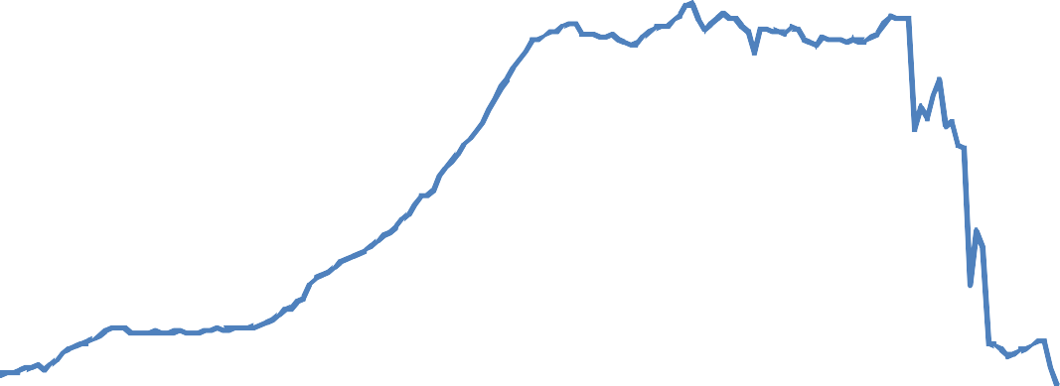

25

20

15

10

5

0

1969

1971

1973

1974

1976

1978

1980

1982

1984

1985

1987

1989

1991

1993

1995

1996

1998

2000

2002

2004

2006

2007

2009

2011

Sources: ONS, Bank of England.

(a) The M4 series excludes intermediate OFCs from Dec 1997. The now discontinued M0 series is used as the denominator until August 1997, from then on it is the sum of MFIs’ ‘Other deposits with the Bank of England’ (including reserves) and ‘Notes and coin’ in circulation. All series apart from ‘Other deposits with the Bank of England’ have been seasonally adjusted.

The MPC loosened monetary conditions in order to meet the Bank’s inflation target in the face of a downturn almost unprecedented in modern economic times. The MPC’s forecasts suggested that without this loosening, which involved an increase in the amount of reserves, inflation would have undershot its target in the medium term. Measures of underlying inflation, which attempt to exclude the influences of one-off shocks on the price level from the headline inflation rate, were volatile but taken as a whole remained close to target during the past few years (Figure 8). When the MPC’s inflation projections suggest that monetary conditions should be tightened, it will reverse some of the extraordinary stimulus that monetary policy has provided over the past few years.

**Figure 8:** Measures of underlying inflation



Percentage changes on a year earlier

9

8

Average weekly earnings‐based measure of unit labour cost (b)

7

GDP deflator at market prices excluding VAT, duties

and export prices (a)

6

5

4

3

2

CPI (c)

1

0

‐1

2001 2002 2003 2004 2005 2006 2007 2008 2009 2010 2011 2012

Sources: ONS (including the Labour Force Survey) and Bank calculations.

1. Export prices include a contribution from imported components, so this measure uses an estimate of export prices excluding the contribution from import prices. Quarterly data. The last observation is Q1 2012.
2. Calculated using average weekly earnings data, adjusted using the ratio of National Accounts compensation and wages and salaries data, and divided by output per worker. Quarterly data. The last observation is Q1 2012.
3. CPI figures are monthly. The last observation is July 2012.

### What should the post-crisis monetary policy framework look like?

The way in which the Bank implements monetary policy has changed substantially since the start of the crisis8. Some of the changes are temporary – I believe, for example, the main policy instrument will again be Bank Rate, not purchases and sales of gilts. But other changes will be more long lasting. For example although the FLS (and the SLS before it) are designed to be temporary schemes, the liquidity insurance

8 A review by Bill Winters is currently being conducted into the bank’s framework for providing liquidity to the banking system. See [http://www.bankofengland.co.uk/publications/Pages/news/2012/049.aspx.](http://www.bankofengland.co.uk/publications/Pages/news/2012/049.aspx)

facilities introduced since 2007-08 have become part of the Bank’s permanent Sterling Market Framework. And the Bank will probably operate permanently with a substantially larger balance sheet: banks have learnt that they took excessive liquidity risks before the crisis, and are likely to want to hold substantially higher levels of liquid assets in future (Figure 9). Some of these assets are likely to be held in the form of central bank reserves.

**Figure 9**: Sterling liquid assets relative to total asset holdings of the UK banking sector (a) (b)

## 35

Broad ratio (c)

Reserve ratio (d) Narrow ratio (e)

30

25

20

15

10

5

0

1967 1972 1977 1982 1987 1992 1997 2002 2007 2012

Sources: Bank of England and Bank calculations.

1. Data for building societies are included from 2010 onwards. Prior to this, data are for UK banks only.
2. Data are end-year except for 2012 where end-April data are used.
3. Cash + Bank of England balances + money at call + eligible bills + UK gilts.
4. Cash + Bank of England balances + eligible bills.
5. Proxied by: Bank of England balances + money at call + eligible bills.

I want to look at three specific questions about policy in the future. First, whether there is a compelling argument against continuing to remunerate reserves at Bank Rate and allowing banks to choose their reserve targets; second, whether the inflation target should be raised to reduce the likelihood that the monetary policy stance is too tight even with Bank Rate at (almost) zero; and third, whether the inflation targeting regime should be changed.

In the pre-crisis system of implementing monetary policy banks chose, subject to some restrictions, the level of their reserve targets. This system effectively reduces private banks’ opportunity cost of holding reserves to zero – banks could repo assets to the Bank of England in exchange for reserves and be charged Bank Rate, and then earn Bank Rate on those reserves so long as they stayed close to their pre-agreed reserves target. I think this system has the great advantage of not penalising banks for holding the most liquid of

assets (bank reserves) by keeping their effective price close to the Bank’s cost of creating them – which is virtually zero.

This arrangement is in the spirit of Friedman’s principle, which is that the opportunity cost of holding money faced by private agents should be zero because the social cost of creating reserves is zero. (For a recent re-statement of the result see also Curdia and Woodford, 20119.)

Should the level of the inflation target be changed? One argument for raising the inflation target is that with higher average inflation, the chances that the central bank is constrained by a zero lower bound on the nominal interest rate it controls are lower. With inflation at 5%, setting Bank Rate to zero would reduce the real interest rate to -5%, whereas with inflation at 2%, setting Bank Rate to zero would ‘only’ reduce the real interest rates to -2%. So to reduce the chances of the lower bound on interest rates becoming a constraint on policy it might seem sensible to raise the target.

I do not find this argument compelling. Elevated levels of inflation are costly for households and firms: prices need to be changed more frequently, or else they become more dispersed across firms. In addition, a higher average rate of inflation has historically meant higher volatility of inflation making it more difficult for people to compare prices. And the benefits of raising the inflation target appear small.

First, the central bank does not become powerless when Bank Rate reaches zero. It can further loosen monetary policy by engaging in asset purchases, or by increasing the amount of liquidity insurance that it provides to the banking sector.

Second, it strikes me as far more likely that a desirable way to respond to the problems we have faced in recent years is to have banks use more capital (equity funding). With the benefit of hindsight the amount of capital banks had pre-crisis was remarkably (indeed ridiculously) low. One of the reasons why the sharp reduction in Bank Rate had a less expansionary effect than one might have hoped was that the funding cost of bank-dependent borrowers remained elevated. The reason was (and is) that banks are perceived to be quite risky. One way of ensuring that bank funding costs respond more to a reduction in Bank Rate is to make them safer by requiring them to use more capital. Higher capital increases banks’ resilience, reducing their borrowing costs. Higher levels of capital also help finance lending directly: capital is lent out – it is not kept in a vault.

What about the inflation targeting regime itself? Economists have discussed for many years whether the central bank’s target should include other things besides inflation. The argument in favour – to boil it down to its most simple – is that targeting inflation is too narrow. I do not find this very compelling either – and many

9 Curdia, V. and Woodford, M. (2011) ‘The central-bank balance sheet as an instrument of policy’, *Journal of Monetary Economics*, 58, pp 54-79; for the original statement of the principle see Friedman, M. (1959), ‘A Program for Monetary Stability’, New York: Fordham University Press.

of the arguments against inflation targeting are in fact arguments against inflexible inflation targeting rather than against having an inflation target guide policy. Self evidently inflation is affected by a wide range of macroeconomic variables, including asset prices, credit growth, the saving plans of households and the change in the supply capacity of the economy. Ultimately inflation reflects the relative size of the demand for output and the supply capacity of the economy – which in turn depends upon the supply of labour and saving from households. In the light of this the idea that focusing on inflation means focusing on some narrow aspect of economic activity has always struck me as bizarre.

**Figure 10:** CPI inflation rate and longer-term inflation expectations (a)

## per cent Citigroup/You Gov 5‐10 ys 6

CPI

Barclays BASIX 5 year Bank/NOP 5‐year

5

4

3

2

1

0

2005 2006 2007 2008 2009 2010 2011 2012

Sources: Bank of England, Barclays Capital, Citigroup, GfK NOP, YouGov, ONS and Bank calculations.

(a) The questions on inflation expectations ask about expected changes in prices, but do not reference a specific price index. Inflation expectation measures are based on the median estimated price change. Data are not seasonally adjusted. The last CPI observation is July 2012; it is 2012Q3 for the Bank/NOP and Barclays surveys, and August 2012 for the Citi/YouGov survey.

Inflexible inflation targeting – by which I mean the strategy of setting policy to bring inflation back to target in the shortest period possible irrespective of why it has been blown away from that target – is not at all desirable. Inflexible targeting is essentially the same thing as focusing on contemporaneous inflation. The MPC does not attempt to target contemporaneous inflation, but inflation in the medium term, and its mandate explicitly allows it to let inflation temporarily deviate from the inflation target to avoid excessive volatility of output. This enables the MPC to look through one-off price level shocks. The past few years illustrate the advantages of having such a flexible inflation targeting regime. While one-off price level shocks increased headline CPI inflation to far above the target, the MPC continued to loosen the monetary policy stance, countering the enormous recessionary forces we have faced. To have not done so would – I believe – have created hugely higher unemployment and a deeper slump in activity and that would have meant the inflation

rate – which is today quite close to 2% – would probably sit far beneath it. During this period of exceptionally easy monetary policy longer-term inflation expectations remained relatively stable (Figure 10).

The inflation targeting regime did not prevent monetary policy being moved in response to the recession – exactly the opposite is true. Some have said this is because the inflation targeting regime was abandoned. This is not at all how it felt to me on the MPC and Figure 10 suggests it was not how it seemed to most people.

### How might we get back to more normal conditions?

A rapid return to more normal monetary policy is not imminent. But thinking through how this might ultimately be done is essential to working out how much further from normal one should go. One would certainly want to know how the brakes on a car work and how to engage reverse gear before you decide how much faster and further to drive forward.

The timing and the speed of reversing the unusually accommodative monetary policy stance will be determined by the outlook for inflation – as was the timing and speed of lowering Bank Rate, of purchasing assets, and of extending the Bank’s lending facilities. There are many ways in which monetary policy could come to be normalised. This raises a question of sequencing: should Bank Rate be increased first, or should the Bank first reduce its portfolio of gilts?

I believe there are likely to be advantages to raising Bank Rate first, and I would expect this to be the strategy10. First, the costs of reversing any premature tightening would appear to be lower. And second, it may have advantages for financial stability because some banks and building societies have indexed a substantial proportion of their lending to Bank Rate, while their funding costs depend on market conditions. So keeping Bank Rate low squeezes the margins of these financial institutions and weakens them.

Let me explain the first point in a bit more detail. At some point it will seem right to scale back the degree to which monetary policy is exceptionally expansionary. No one will be sure when that time has come. If you waited until it was absolutely clear that policy needed to be less expansionary you have almost certainly waited too long. So in the months after the first tightening move, there is a considerable probability that the MPC would have to reverse course and loosen monetary policy.

Were the first tightening move to be a sale of a proportion of the Bank’s holdings of gilts while Bank Rate is still close to zero, reversing the tightening would require the Bank to repurchase (some of) the gilts it had just sold. Reversing the trajectory of gilt holdings would create unnecessary volatility in the market for gilts. Put

10 See Mervyn King’s 2010 Mansion House speech. This is available at [http://www.bankofengland.co.uk/publications/Documents/speeches/2010/speech437.pdf,](http://www.bankofengland.co.uk/publications/Documents/speeches/2010/speech437.pdf)

more positively, a pre-announced auction schedule, such as that envisaged in the Bank’s discussions with the Debt Management, provides predictability that minimises disruption.

**Table 1**: Cumulated coupon and principal payments originating from gilt purchases up to end-August 2012

|  |  |
| --- | --- |
|  | **Cumulated coupon payments Cumulated payments of principal (£bn) (£bn)** |
| up to end-Aug 2012 | 28 0 |
| up to end-2015 | 74 52 |
| up to end-2019 | 114 124 |
| up to end-2027 | 162 206 |
| until the last gilt in the APF portfolio has matured | 216 304 |

Source: Bank of England. Cumulated gilt purchases were £347.75bn on 31 August 2012.

In contrast, if the first tightening were to be an increase in Bank Rate, that rate could be lowered again if necessary. The associated costs should be smaller because market participants are used to variations in Bank Rate. Once Bank Rate has reached a level at which only a remote possibility remains of having to quickly lower Bank Rate again to almost zero, the Bank could tighten monetary conditions by selling gilts.

In the meantime, the portfolio of gilts might already start to shrink for two reasons. First, the Bank has not so far reinvested the coupon payments it receives on the gilts11. And second, the first gilts in its portfolio will mature from 2013 onwards (Table 1). Table 1 shows that by the end of 2015 about £126 billion of coupons and redemptions would have been generated by the existing stock of gilts the Bank has bought.

### Conclusion

Monetary Policy has been set in ways that are exceptional – rightly so, since we have been dealing with the aftermath of a huge and global crisis. The blurring of lines between fiscal and monetary policy is inevitable once the policy rate becomes close to zero so that policy can be only made significantly more expansionary by the central bank expanding its balance sheet. That blurring does not mean that the aims of monetary policy have become unclear – it is still being conducted with an inflation target as the guiding light. Rather than the focus on inflation being an unhelpful constraint on policy it is the natural means by which one judges how expansionary monetary policy should be. Once one takes account of the dependence of the setting of monetary policy on the inflation outlook the apparent advantages in boosting demand of the monetisation of government spending (or helicopter drops), relative to conventional QE, largely evaporates. Because QE

11 Most gilts were bought at above par since the yields were below the coupon rate. This means that the value of the gilts is likely to decline slightly if none of the coupons is re-invested.

takes the inflation outlook explicitly into account, monetisation of government debt has no clear advantages over QE.

The forces unleashed by the financial crisis that began 5 years ago have been extraordinarily damaging to incomes and wealth. The banking system across much of the rich, western world remains damaged.

Monetary policy in the UK has been set to its most expansionary setting in history; and I believe it is right that it is still being moved further in that direction. But economic activity has not collapsed; unemployment has risen but has not exploded and inflation has neither soared nor become entrenched at a negative rate. I do not consider this a great success. Perhaps the most one could say is that the boat has not capsized even though the steering wheel has been turned exceptionally hard in one direction.

Some people conclude from this that the charts we had to guide setting economic policy – largely created by economists – have been proved useless for navigation. I think that this is both nihilistic and naïve. If I thought that economics had somehow been proved useless – or just plain wrong – I would conclude tonight by suggesting the Scottish Economic Society find a new name. But I don’t see any reason to do that. And I do not think that Adam Smith or David Hume would either.

### APPENDIX

The Nobel Prize in Economics

Those for whom incomplete markets, or asymmetric information, or moral hazard-adverse selection, or externalities, or coordination problems are central (**33 winners**): Paul Samuelson (1970); John Hicks, Kenneth Arrow (1972); Gunnar Myrdal (1974); James Meade (1977); Herbert Simon (1978); James Tobin (1981); Franco Modigliani (1985); Robert Solow (1987); Douglass North (1993); John Harsanyi,

Reinhard Selten, John Nash (1994); James Mirrlees; William Vickrey (1996); Amartya Sen (1998); George Akerlof, Michael Spence, Joseph Stiglitz (2001); Daniel Kahneman, Vernon Smith (2002); Robert Aumann, Thomas Schelling (2005); Edmund Phelps (2006); Leonid Hurwicz, Eric Maskin, Roger Myerson (2007); Paul Krugman (2008); Elinor Ostrom, Oliver Williamson (2009); Peter Diamond, Dale Mortensen, Christopher Pissarides (2010).

Those for whom those issues are not very relevant (**17 winners**): Ragnar Frisch, Jan Tinbergen (1969); Simon Kuznets (1971); Wassily Leontief (1973); Leonid Kantorovich, Tjalling Koopmans (1975); Bertil Ohlin (1977); Theodore Schultz, Sir Arthur Lewis (1979), Lawrence Klein (1980); Richard Stone (1984);

Maurice Allais (1988); Trygve Haavelmo (1989); James Heckman, Daniel McFadden (2000); Robert Engle III, Clive Granger (2003)

Those for whom even though information issues are central the laissez faire outcomes are still likely to be the best realistically available (**19 winners**): Friedrich von Hayek (1974); Milton Friedman (1976);

George Stigler (1982); Gerard Debreu (1983); James Buchanan (1986); Harry Markowitz, Merton Miller, William Sharpe (1990); Ronald Coase (1991); Gary Becker (1992); Robert Fogel (1993); Robert Lucas Jr. (1995); Robert Merton, Myron Scholes (1997); Robert Mundell (1999); Finn Kydland, Edward Prescott (2004); Thomas Sargent, Christopher Sims (2011).